Ancient Egypt Map

Directions: Use the maps in your textbook to complete the map.

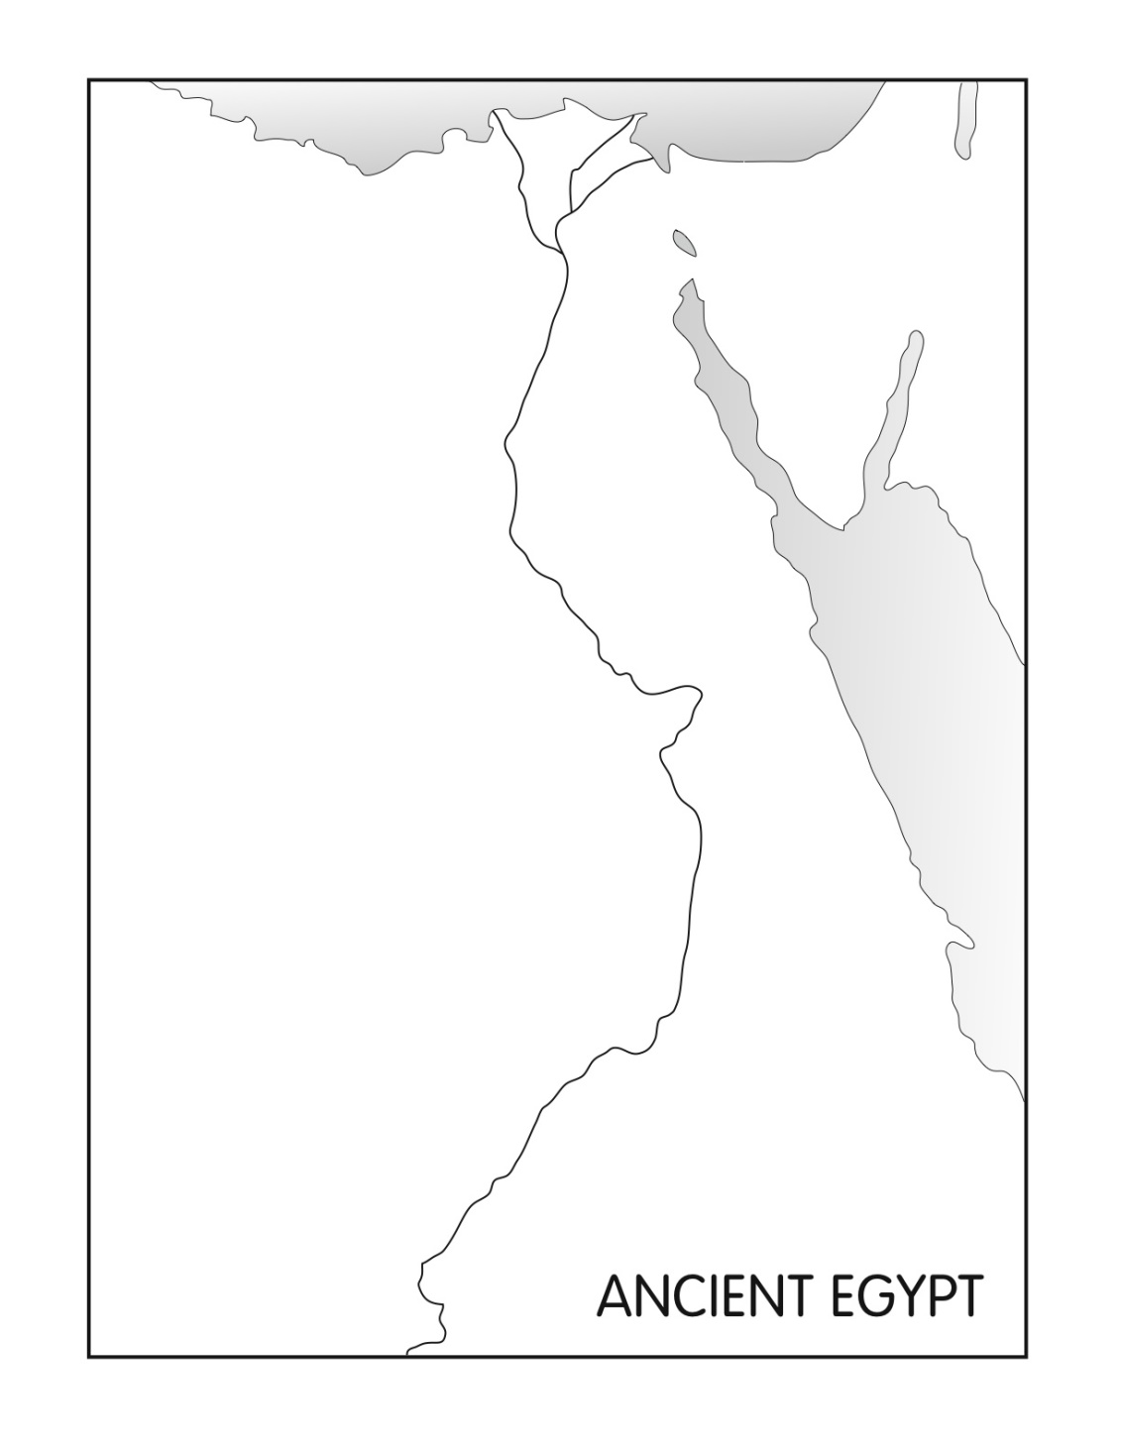

**Label and color BLUE:**

* Mediterranean Sea
* Red Sea
* Nile River

**Label & color PURPLE:**

* Egyptian Empire

**Label & color YELLOW:**

* Arabian Peninsula
* Libyan Desert

**Label & dot the cities:**

* Jerusalem
* Giza Memphis
* Aswan
* Napata

**Label & star the capital:**

* Thebes

**Label:**

* Lower Egypt
* Upper Egypt

**Label and draw the line for the Tropic of Cancer.**  
 **- - - - - - - - -**



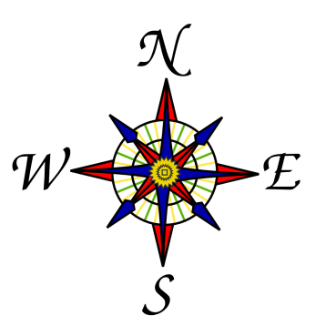

Key

**Complete the KEY by adding symbols and colors for waters, deserts, cities, capitals, and the Egyptian Empire.**